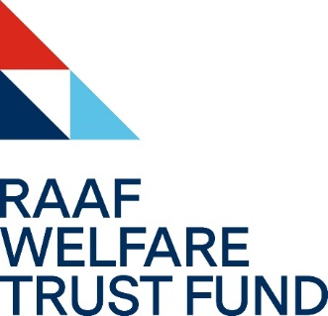

FREEDOM OF INFORMATION DISCLOSURE LOG

The Royal Australian Air Force Welfare Trust Fund (RWTF) Freedom of Information (FOI) disclosure log provides information released in response to a FOI request for access to documents. RWTF publishes information released under section 11A of the Freedom of Information Act 1982 (FOI Act).
The disclosure log requirement does not apply to:
- personal information about any person if publication of that information would be ‘unreasonable’
- information about the business, commercial, financial or professional affairs of any person if publication of that information would be ‘unreasonable’
- other information covered by a determination made by the Australian Information Commissioner if publication of that information would be ‘unreasonable’
- any information if it is not reasonably practicable to publish the information because of the extent of modifications that would need to be made to delete the information listed in the above dot points.
Deletions have been made to the documents in accordance with the exemptions available under the FOI Act.
Information published in the disclosure log is removed after 2 years.
Date | Details

Last updated 26 Aug 26.

